Static flow
whenever we are executing a java class the following sequence of steps or activity will be executed at the part of static control flow.
1.identification of static members from top to bottom[1 to 6]
2.execution of static variable assignment and static block from top to bottom[7 to 12]
3.execution of main method.[13 to 15]
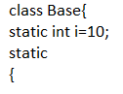 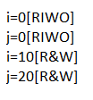
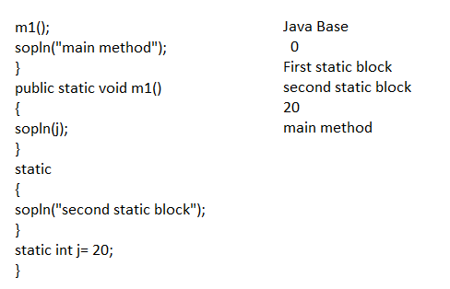
RIWO--------------------→read indirectly write only
Note:
Inside a static block if we try to read a variable that read operation is called direct read
if we are calling a method and within the method if we are trying to rad a variable that read operation is called indirect read.
example:
class Test
{
static int i=10;
static
{
m1();
sop(i);
}
psvm()
{
sop(i);
}
}
NOTE: if a variable just identify the JVM and the original value not yet decide them the variable is said to be in RIWO statement.
if variable is in read indirectly write only state then we cant perform direct read but we can perform indirect read
if we are trying to rea directly then we will get compile time error saying
“illegal forward reference”
examples:
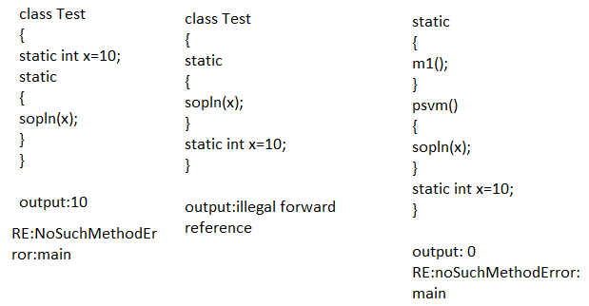
Static block will be executed at the time of class loading hence at the time of class loading if you want to perform any activity we have to define that inside the static block.
example1:
at the time of java class loading the corresponding native libraries should be loaded hence we have to define this activity inside the static block
class Test
{
static
{
System.loadLibrary(“native library loaded”);
}
}
example:
After loading every database driver class we have to register driver class with driver manager but inside data base driver class there is a static block to perform this activity and we are not responsible to register explicitly
class DbDriver
{
static
{
Register this Driver wth DriverManager
}
}
Note:
within a class we can declare any no of static block but all this static block will be executed from top to bottom.
Q:without writing main method is it possible to print some statement to the console?
A:yes, by using static block
example :
class Test
{
static
{
sop(“hello”);
}
}
o/p: hello
Q:without writing main method and static block is it possible to print some statement to the console?
A:yes.
example:
class Test
{
static int x=m1();
public static int m1()
{
sop(“hi”);
System.exit(0);
return 10;
}
}
o/p:hi
example2:
class Test
{
static Test t=new Test();
{
sop(“hi”)
System.exit(0);
}
}
o/p:hi
example:3
class Test
{
static Test t = new Test();
Test()
{
sop(“hi”);
System.exit(0);
}
}
o/p:hi
but 1.7 version onwards main method is mandatory to start program execution, so without writing main method it is impossible to print some statement to the console.
static control flow in parent to child relationship
class Base
{
static int i=10;
static
{
m1();
sop(“base static block”);
}
psvm(String[] args)
{
m1();
sop(“base main”);
}
psvm1()
{
sop(j);
}
static int j=20;
}
****************************************************
Class Derived extends Base
{
static int x=100;
static
{
m2();
sop(“Derived first static block”);
}
psvm(String[] args)
{
m2();
sop(“Derived main”);
}
psvm2()
{
sop(y);
}
static
{
sop(“Derived second static block”);
}
static int y=2000;
}
Steps of execution:
1.Identification of static methods from parent to child
2.execution of static variable assignment and static blocks from parent to child
3.executethe main method of child class.
o/p:
when Derived class runs
0
Base static block
0
Derived First static block
Derived Second static block
200
Derived main
o/p
when Base class run
0
Base static Block
20
Base main
*******************************************************************
i= 0[RIWO]
j=0[RIWO]
x=0[RIWO]
y=0[RIWO]
i=10[R&W]
j=20[R&W]
x=100[R&W]
y=100[R&W]

